# Introduction

The assignment is targeted to test the skills of the candidate in CSS.

# Objective

This assignment will help master the concepts of CSS.

# Pre-requisites

Concepts of HTML.

# Associated Data Files

Completed HTML layout of the previous assignment.

Make sure to complete the previous assignment before starting this.

# Problem Statement

1. Crate a HTML page holding a "Like" button that changes to "Unlike" when clicked, then again to "Like", etc.



1. Write JavaScript code hideOddRows.js that attaches to the button click event and hides the odd rows of the table when clicked.

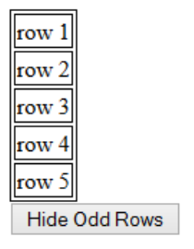

1. Write a HTML page holding a form and a text field. Using JavaScript make the text field to accept numbers only. When a non-number character is entered through the keyboard (or by any other way), make the field red for a while and do not accept the change (preserve the previous value of the field).

